

HOW TO – GDMA Master Server Configuration
(GroundWork Distributed Monitoring Agents V2.1)

Jan 12, 2010
Version 1.1

Prepared by:

Kevin Stone
Table of Contents
Summary 3
Prerequisites 3
Master Server Setup 3
NSCA Communication Setup 3
Create GDMA Build Directory 4
Enable Monarch Externals 4
Auto Configuration Operation 5
Autoconfiguration Setup 6
Upload and Import GDMA Autoconfiguration Profile 6
Create GDMA Autoconfiguration Virtual Host 8
Install GDMA Autoconfiguration scripts and cron entry 9
Figure 1 Poller Operation 10
Figure 2 Spooler Operation 11

Summary

This document describes the steps necessary to configure an existing GroundWork Monitor Enterprise server to support GDMA agents. This document describes a basic installation. For information on advanced configurations contact GroundWork Support.

Prerequisites

The following prerequisites exist for configuration of a GDMA Master Server

- GroundWork Monitor Enterprise 6.0.1 or higher correctly installed.
- Communication allowed from GDMA targets on ports 80 (HTTP) or 443(HTTPS)
- Communication allowed from GDMA targets on port 5667 (NSCA)
- Master Server and GDMA targets clock synchronization
- Administrative access and familiarity with GroundWork, Nagios and Monarch.
- Taking a backup of the monarch database is highly recommended before beginning this operation See Bookshelf →System Maintenance→Backup and Restore for details.

Master Server Setup

NSCA Communication Setup

GroundWork Monitor Enterprise 6.0.1 uses a Nagios Event Broker (NEB) to process passive check results. The NEB is called Bronx. GDMA supports a feature called spooling which will handle network interruptions between GDMA hosts and the GroundWork Monitor server. When that interruption ceases, results are sent back with correct timestamps. To support these timestamps, the Bronx configuration file, /usr/local/groundwork/config/bronx.cfg, listener_max_packet_age parameter needs to be updated. Set this value to 900 seconds to allow for GDMA spooling.

# LISTENER MAX PACKET AGE
# The max allowed age, in seconds, of the passive check result received.
# Any older results are dropped to the floor.
# The maximum allowed value is "900" seconds.
# Set the value to "0" to accept passive checks with older timestamps.
# If not specified, the value will be "30" seconds.
listener_max_packet_age=900

Create GDMA Build Directory

This is the location that will be used for building and distribution of GDMA host configurations.

As user root create the directory and change ownership to user Nagios.

#mkdir /usr/local/groundwork/apache2/htdocs/gdma
#chown nagios.nagios /usr/local/groundwork/apache2/htdocs/gdma

# ls -al /usr/local/groundwork/apache2/htdocs/
total 44
drwxr-xr-x 4 nagios nagios 4096 Nov 11 09:54 .
drwxr-xr-x 15 nagios nagios 4096 Nov 11 08:29 ..
-rw-r--r-- 1 nagios nagios 2205 Dec 14 2005 apache_pb22_ani.gif
-rw-r--r-- 1 nagios nagios 2410 Dec 14 2005 apache_pb22.gif
-rw-r--r-- 1 nagios nagios 1502 Dec 14 2005 apache_pb22.png
-rw-r--r-- 1 nagios nagios 2326 Nov 20 2004 apache_pb.gif
-rw-r--r-- 1 nagios nagios 1385 Nov 20 2004 apache_pb.png
-rw-r--r-- 1 nagios nagios 1150 Jan 22 2009 favicon.ico
drwxr-xr-x 2 nagios nagios 4096 Nov 11 09:54 gdma
-rwxr-xr-x 1 nagios nagios 993 Nov 9 06:46 index.html
drwxr-xr-x 2 nagios nagios 4096 Nov 11 08:30 rrd

Enable Monarch Externals

In Configuration→Control→Setup
Check enable externals
Select Save

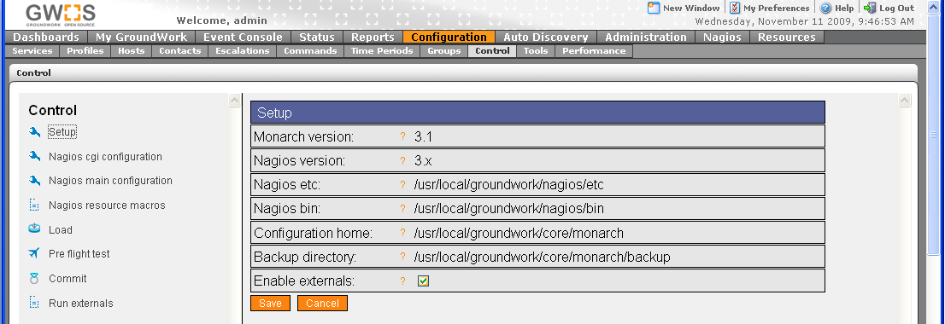

The system is now configured for general GDMA operation. See Configuring Targets Howto’s for target configuration.
Autoconfiguration Theory of Operation

The auto configuration feature of GDMA 2.1 enables GDMA agents to be deployed to target systems without needing to provide a host specific configuration at installation time. When GDMA is first installed and started without a configuration it will operate in Auto Configuration mode. While in Auto Configuration mode the agent will periodically perform a basic discovery of the host system and transmit the discovery information to a pre defined Master system. This information can then be used by the Groundwork system administrator to configure a host specific configuration for the new target host. When the host specific configuration is available it will be retrieved by the agent and the agent will self configure and switch to normal operation.

Auto Configuration Operation

When the agent is first started both the poller and spooler engines are started.

Basic Poller Operation in Auto Configuration mode

- Poller reads gdma_auto.cfg
- Poller checks for the presence of a local host configuration file.
- Poller attempts to retrieve a host configuration file from the location defined by gdma_auto.cfg.
- If it fails to download a host configuration file it sleeps until Poller_Proc_Interval has expired and starts at step 1

Basic Spooler Operation in Auto Configuration mode

- Spooler reads gdma_auto.cfg
- Spooler checks for the presence of a local host configuration file.
- If the host configuration file is not present the spooler transmits an auto configuration message.
The message is sent via NSCA as a service check result.
The target host,service = GDMA_Auto_Host ,GDMA_Auto_Service.
The message payload contains the hostname, ip address and operating system information.
Example:

- Spooler sleeps until Spooller_Proc_Interval has expired and restarts starts at step 1

Autoconfiguration Setup

Upload and Import GDMA Autoconfiguration Profile
The GDMA Autoconfiguration profile provides a template for the autoconfiguration virtual host.

In Configuration→Profiles
- Select Profile importer
- Scroll to bottom of screen
- Select Browse and enter location of “gdma_autohost.xml”
- Select upload
- Select Browse and enter location of “service-profile-gdma_auto.xml”
- Select upload

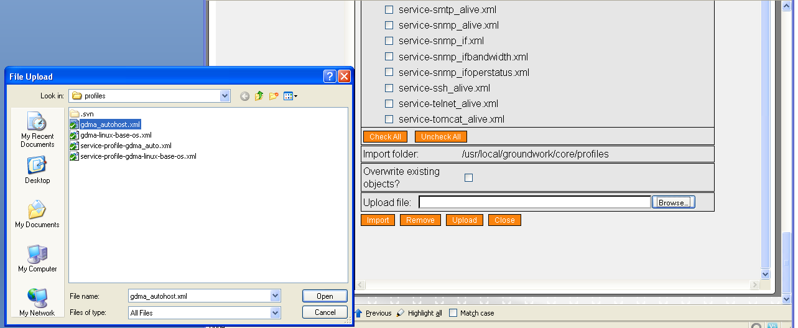

- Toggle Checkbox for gdma_autohost.xml

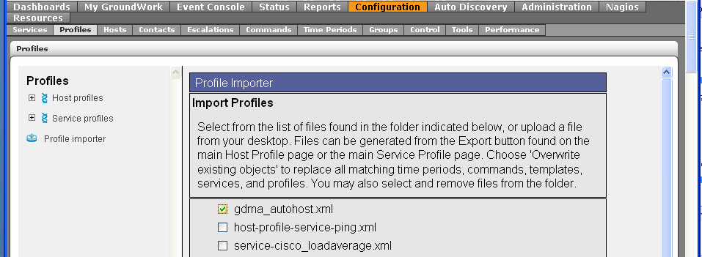
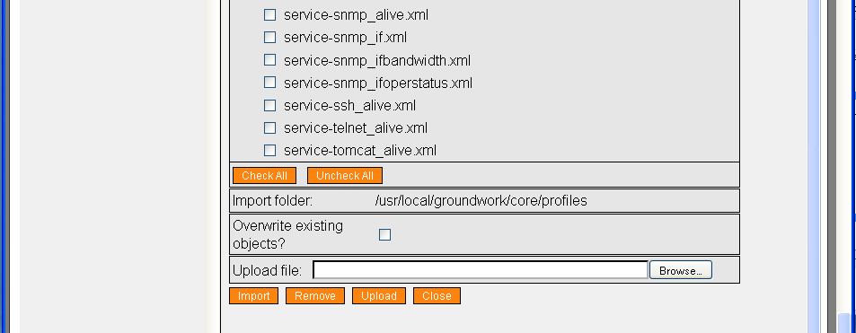

- Select Import
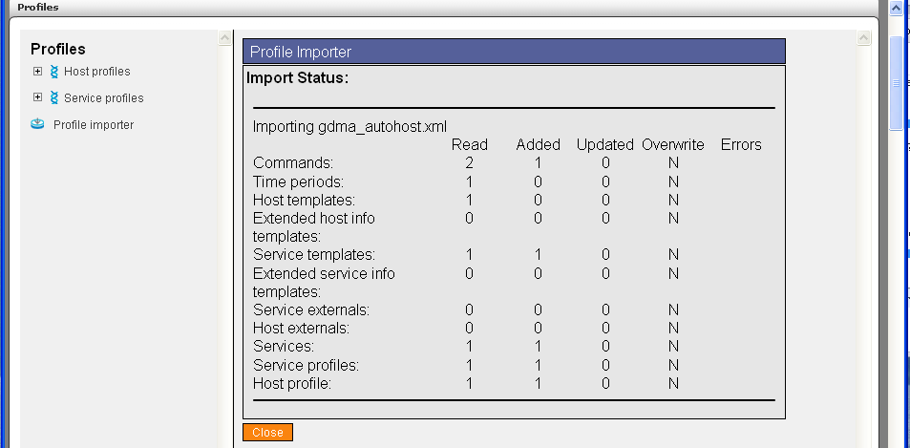

Create GDMA Autoconfiguration Virtual Host
This virtual host serves as a collection point for notifications and alerts from unconfigured GDMA agents.

In Configuration→Hosts
- Select Host Wizard
- Fill in Host Name “gdma_autohost”
- Fill in alias “gdma_autohost”
- Fill in address “127.0.0.2”
- Select gdma_autohost Host profile

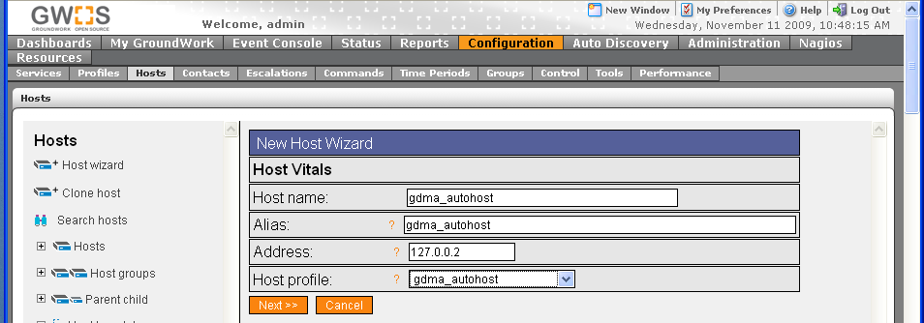

- Select Next,Next,Next,Next,Continue. Note: if you are using clone host or another method for creating this host, please ensure it has no externals associated, or you may see an error when running externals related to the distribution directory. The gdma_autohost and it’s services should have no externals.
- Commit Changes to activate

The system is now configured to receive auto configuration messages from GDMA targets.

Install GDMA Autoconfiguration scripts and cron entry
The GDMA Master Server can be configured to automatically add unconfigured hosts to Monarch and generate the External configuration files. This feature is currently only supported when the GDMA Master Server is running GroundWork Monitor 6.1 Enterprise.

Setup is done by installing two scripts on the Master and then enabling a cron job to regularly look for and add the new hosts.

As user root, unpack the GDMA 2.1 auto registration files into a temporary directory, copy the two Perl scripts to the required location, and then change ownership to user Nagios.

#cp *.pl /usr/local/groundwork/core/monarch/automation/scripts
#chown nagios.nagios /usr/local/groundwork/core/monarch/automation/scripts/gdma_auto.pl
#chown nagios.nagios /usr/local/groundwork/core/monarch/automation/scripts/auto_add_gdma.pl

Create the cron job by entering the crontab editor and then typing in the single line to run the above scripts.

#crontab –e –u nagios
SHELL=/bin/bash
PATH=/usr/local/groundwork/common/bin:/usr/local/groundwork/common/sbin

50 23 * * * /usr/local/groundwork/core/reports/utils/dashboard_data_load.pl > /usr/local/groundwork/core/reports/utils/log/dashboard_data_load.log 2>&1
0 1 * * * /usr/local/groundwork/core/reports/utils/dashboard_avail_load.pl > /usr/local/groundwork/core/reports/utils/log/dashboard_avail_load.log 2>&1
0 0 * * * /usr/local/groundwork/common/bin/find /tmp/ -maxdepth 0 -name 'sess_*' -cmin +480 -exec rm \{} \;
0 0 * * * /usr/local/groundwork/common/bin/find /usr/local/groundwork/php/tmp/ -maxdepth 0 -name 'sess_*' -cmin +480 -exec rm \{} \;
0 0 * * * /usr/local/groundwork/common/bin/find /usr/local/groundwork/nagios/var/archives/ -follow -name 'nagios-*' -mtime +60 -exec rm \{} \;
*/5 * * * * (cd /usr/local/groundwork/core/monarch/automation/scripts ; ./gdma_auto.pl ; ./auto_add_gdma.pl –f ../data/gdma_auto.txt) > /dev/null 2>&1

GDMA Master Server configuration is now complete. See GDMA Unix Target or Windows Target Howto’s for information on configuring GDMA agents.

Figure 1 Poller Operation
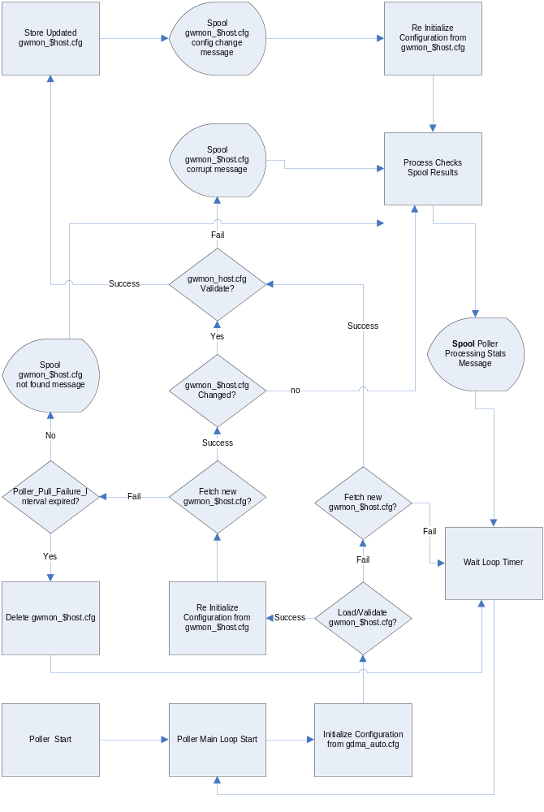
Figure 2 Spooler Operation
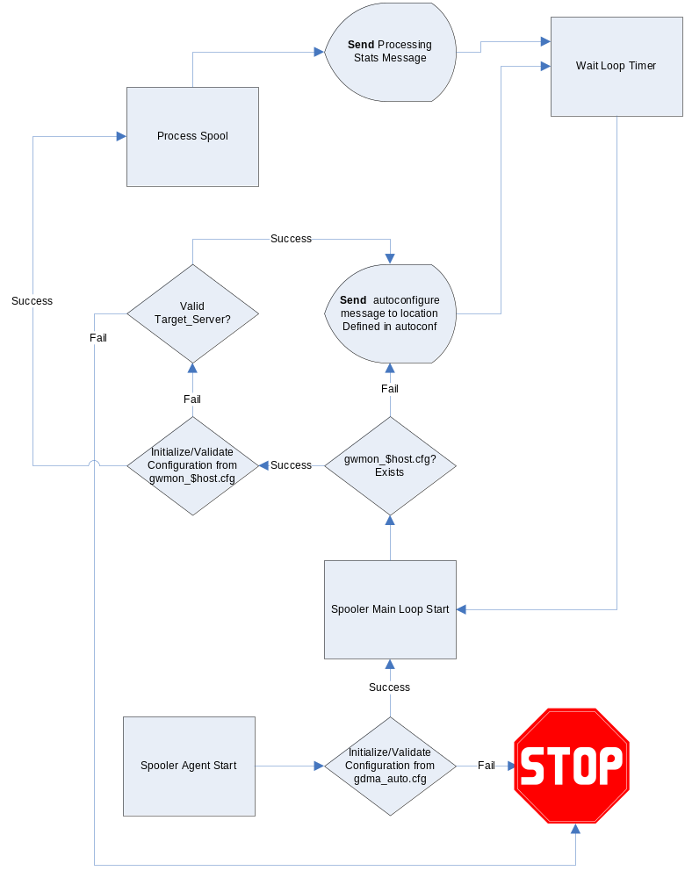

GDMA operation requires a unified time base for master systems and the target systems. This is normally accomplished using an external clock source such as NTP (Network Time Protocol) for all systems. Messages from systems with out of sync clocks will be dropped silently by Bronx.
See Fig 1, Poller Operation for details
See Fig 2, Spooler Operation for details
This name is controlled by the GDMA_Auto_Host Configuration parameter. Do not modify this path without consulting GDMA agent documentation.
Nagios and Groundwork require that all IP addresses for configured hosts be unique. Ensure that the address used here is unique in the configuration.
You may optionally place the gdma_autohost in a hostgroup and configure notification options.

